**FINDING THE CORRECT POSITION**

# *WITHOUT THE RACKET*

1ST Progression

Roll the ball on the floor to the right hand side of the player. The player makes a split step then moves and kicks the ball with the inside of the right foot

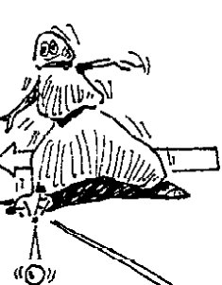

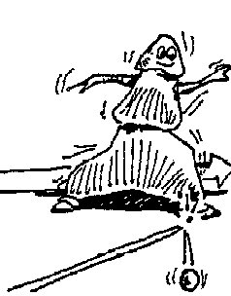

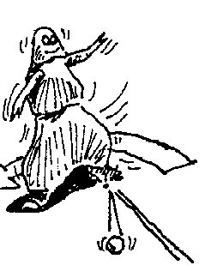

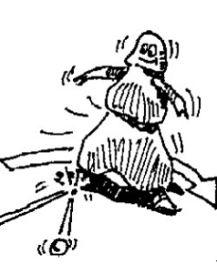

2nd Progression

Roll the ball on the floor to the left hand side of the player. The player makes a split step then moves and kicks the ball with the inside of the left foot

3rd Progression

Roll the ball on the floor to the right hand side of the player. The player makes a split step then moves and kicks the ball with the inside of the left foot

4th Progression

Roll the ball on the floor to the left hand side of the player. The player makes a split step then moves and kicks the ball with the inside of the right foot

*Notes*

**FINDING THE CORRECT POSITION**

# *WITHOUT THE RACKET*

5th Progression

Throw the ball to the right hand side of the player. The player makes a split step then moves and catches the ball with their right hand

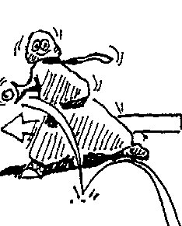

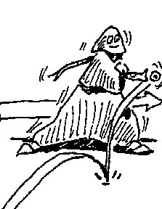

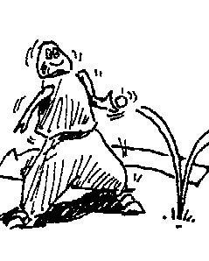

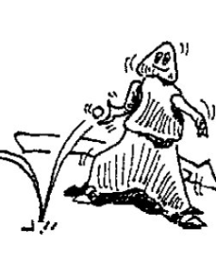

6th Progression

Throw the ball to the left hand side of the player. The player makes a split step then moves and catches the ball with their left hand

7th Progression

Throw the ball to the right hand side of the player. The player makes a split step then moves and catches the ball with their left hand

8th Progression

Throw the ball to the left hand side of the player. The player makes a split step then moves and catches the ball with their right hand

*Notes*

**FOREHAND VOLLEY**

# *TEACHING PROGRESSIONS*

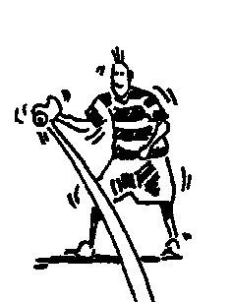

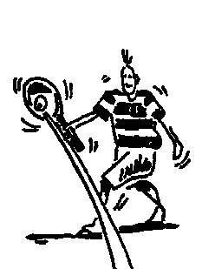

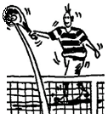

1ST Progression

Start from the ready position. Have the player block the ball back without it bouncing to their partner using the palm of the hand.

2nd Progression

Start from the ready position. Have the player block the ball back without it bouncing to their partner holding the racket at the top of the grip.

3rd Progression

Start from the ready position. Have the player block the ball back without it bouncing to their partner holding the racket at the bottom of the grip from a ball that is thrown to them.

The progressions are taught within the whole stroke.

The key elements of the stroke include:-

* Ready Position
* Preparation
* Drive position
* Contact
* Finish

**BACKHAND VOLLEY**

# *TEACHING PROGRESSIONS*

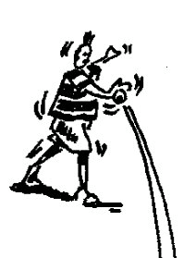

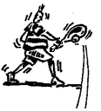

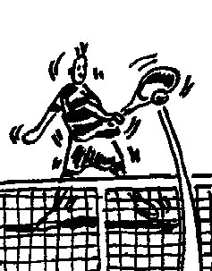

1ST Progression

Start from the ready position. Have the player block the ball without it bouncing to their partner with the back of their hand.

2nd Progression

Start from the ready position. Have the player block the ball back without it bouncing to their partner holding the racket at the top of the grip from a ball that is thrown to them.

3rd Progression

Start from the ready position. Have the player block the ball back without it bouncing to their partner holding the racket at the bottom of the grip from a ball that is thrown to them.

The progressions are taught within the whole stroke.

The key elements of the stroke include:-

* Ready Position
* Preparation
* Drive position
* Contact
* Finish

**FOREHAND GROUNDSTROKE**

# *TEACHING PROGRESSIONS*

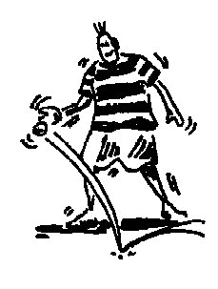

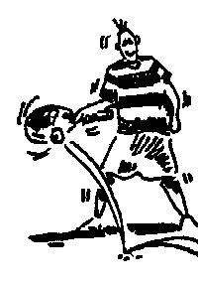

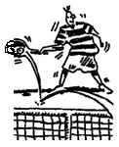

1st Progression

Start from the ready position. Have the player hit the ball with the palm of their hand after it has bounced back their partner. The player should follow through with the hand by the side of the ear with the palm facing outwards.

2nd Progression

Start from the ready position. Have the player hit the ball back after it has bounced back to their partner holding the racket at the top of the grip. The player should follow through with the hand by the side of the ear with the palm facing outwards.

3rd Progression

Start from the ready position. Have the player hit the ball back after it has bounced to their partner holding the racket at the bottom of the grip from a ball that is thrown to them. The player should follow through with the hand by the side of the ear with the palm facing outwards.

The progressions are taught within the whole stroke.

The key elements of the stroke include:-

* Ready Position
* Preparation
* Drive position
* Contact
* Finish

**1 HANDED BACKHAND GROUNDSTROKE**

# *TEACHING PROGRESSIONS*

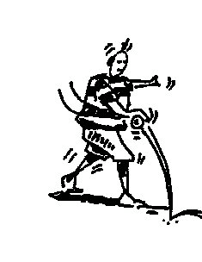

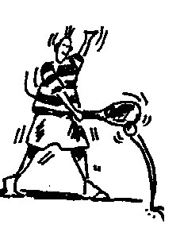

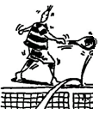

1st Progression

Start from the ready position. Have the player hit the ball with the back of their hand after it has bounced back their partner. The player should follow through with the finger tips pointing to the sky.

2nd Progression

Start from the ready position. Have the player hit the ball back after it has bounced back to their partner holding the racket at the top of the grip. The player should follow through with the tip of the racket pointing to the sky and the racket head parallel to the sideline.

3rd Progression

Start from the ready position. Have the player hit the ball back after it has bounced back to their partner holding the racket at the bottom of the grip. The player should follow through with the tip of the racket pointing to the sky and the racket head parallel to the sideline.

The progressions are taught within the whole stroke.

The key elements of the stroke include:-

* Ready Position
* Preparation
* Drive position
* Contact
* Finish

**2 HANDED BACKHAND GROUNDSTROKE**

# *TEACHING PROGRESSIONS*

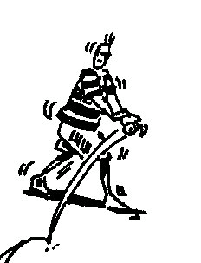

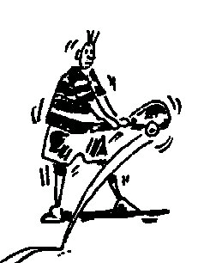

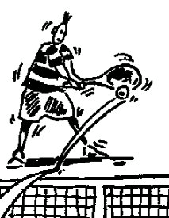

1st Progression

Start from the ready position. Holding the wrist of their dominant hand with their other hand have the player catch the ball after it has bounced and throw it back to their partner using the back of the hand. The player should follow through with the hands finishing on the opposite shoulder.

2nd Progression

Start from the ready position. Have the player hit the ball back after it has bounced back to their partner holding the racket with both hands at the top of the grip. The player should follow through with the hands finishing on the opposite shoulder.

3rd Progression

Start from the ready position. Have the player hit the ball back after it has bounced back to their partner holding the racket with both hands at the bottom of the grip. The player should follow through with the hands finishing on the opposite shoulder.

The progressions are taught within the whole stroke.

The key elements of the stroke include:-

* Ready Position
* Preparation
* Drive position
* Contact
* Finish

**SERVICE**

# *TEACHING PROGRESSIONS*

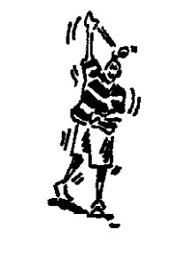

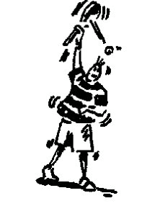

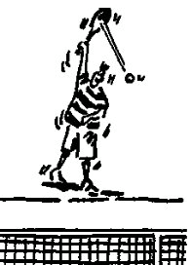

1st Progression

Have the player stand sideways. Throw the ball up with their non-playing hand and then hit the ball with their dominant hand with the arm fully stretched and then throw the ball over the net finishing with the thumb on the thigh.

2nd Progression

Have the player stand sideways. Throw the ball up with their non-playing hand and hit the ball holding the racket at the top of the grip with the arm fully stretched. The follow through should finish with the thumb on the thigh.

3rd Progression

Have the player stand sideways. Throw the ball up with their non-playing hand and hit the ball holding the racket at the bottom of the grip with the arm fully stretched. The follow through should finish with the thumb on the thigh.

The progressions are taught within the whole stroke.

The key elements of the stroke include:-

* Ready Position
* Preparation
* Drive position
* Contact
* Finish