COURSE APPLICATION
Community Coach Application Form
Please send this application form together with your payment of £XXXXXXX to: -
XXXXXXXXXXXXXXXXXX

The course fee includes the relevant study materials, RPT testing fee

If paying by cheque please make cheque payable to “INSERT YOUR DETAILS HERE”

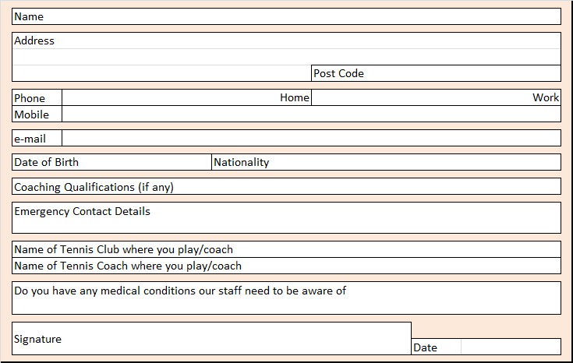

Credit Card Payments

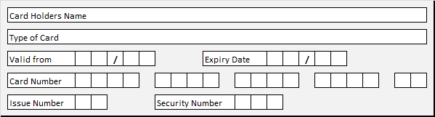

DECLARATION & TERMS & CONDITIONS

I understand and agree that:

- I must attend all the scheduled sessions during the course in the correct sequence and at the agreed venue, to qualify for assessment. I understand that I cannot miss parts of the course or move between venues unless my circumstances are exceptional (medical only, supported by a doctor’s note); you must complete the course within a maximum of 6 months from the date of your enrolment.

- If I withdraw from the course I will forfeit the course fee, unless I give at least 21 working days written notice prior to the commencement of the course. If I give less than 21 working days written notice the fee will not be forfeited if the RPT is able to fill the vacancy;

- If I withdraw from the course once it has started, I will forfeit the fee;

- The RPT is not liable for any damage or loss caused during this application process or for the duration of the course save where this is caused by the negligence of the RPT, its employees and directly affiliated bodies but any such liability shall be limited to the extent that such loss was reasonably foreseeable at the time the contract was entered into. For the avoidance of doubt this clause in no way excludes or limits the liability for personal injury or death caused as a result of the negligence of the RPT, its employees and affiliated bodies;

- The RPT reserves the right to cancel the course if enrolment numbers are not sufficient;

- The RPT reserves the right to reject any applicant whom it considers to be an unsuitable person for involvement in tennis coaching. This right may also be exercised retrospectively if information is brought to the RPT’s attention, which, if known at the time of application, would have rendered the candidate unsuitable. For the avoidance of doubt, the falsification of any information requested in this application form and/or the existence of any police record or caution relating to matters considered to be incompatible with certification, constitute circumstances where the RPT reserves the right to withdraw or suspend a candidate’s qualification.

- I agree to complete my portfolio by the final day of the course and understand that until I do so my RPT certification will not be processed.

Signature | Date

By signing this form I agree to work to the best of my ability at all times, to uphold the European code of Sport Ethics and the European Charter for Sport. I also acknowledge that I have never been convicted of a criminal offence or been the subject of a Caution or of a Bound Over Order. I also promise to work within the guidelines for child protection laid down by the Governing Body in this country and within the parameters of the RPT child protection policy.

From time to time we receive requests from companies that could offer you additional benefits and services. If you do not wish your details to be passed on to these carefully approved companies then please tick this box [ ]

